Data Quality And Validation
In ETL
Question no 1:
Define Data Quality in the context of ETL pipelines. Why is it more than just data cleaning?
Answer:
Data quality in ETL (Extract, Transform, Load) pipelines refers to the, "assurance that data is accurate, complete, consistent, timely, and valid for its intended business purpose". It focuses on ensuring data is reliable from ingestion to storage, transforming raw data into trustworthy assets rather than just cleaning it.
Why Data Quality is More Than Just Data Cleaning:
- Proactive vs. Reactive: Data cleaning is a reactive, one-time fix for existing errors (e.g., removing duplicates). Data quality is proactive, establishing rules, preventing errors during ingestion, and ensuring data is fit for purpose.
- Broadened Dimensions: Quality includes dimensions beyond accuracy, such as:
  - Completeness: Ensuring no key fields are missing.
  - Freshness/Timeliness: Data is available when needed.
  - Consistency: Data is consistent across different systems.
  - Validity: Data follows defined formats and rules.
- Business Context & Relevance: Data can be perfectly clean (structurally) but technically irrelevant or useless for the business. Quality ensures data is relevant to the business goal, while cleaning only ensures it fits a technical format.
- Preventative Governance: Data quality is often integrated with governance to prevent bad data from entering the warehouse, whereas cleaning frequently occurs after data has already loaded incorrectly.
Key Data Quality Aspects in ETL:
- Profiling: Analyzing data patterns before transformation.
- Validation Rules: Setting standards (e.g., <5% NULLs) and automating checks (e.g., via AWS Glue Data Quality).
- Monitoring & Alerting: Continually checking data, rather than fixing errors only when they break reports.

Question no 2:
Explain why poor data quality leads to misleading dashboards and incorrect decisions.
Answer:
Poor data quality leads to misleading dashboards and incorrect decisions because visualizations are only as reliable as the underlying data, known as the "Garbage In, Garbage Out" principle. Inaccurate, incomplete, or outdated data creates skewed metrics and false insights, leading leaders to make poor strategic choices based on flawed assumptions.
Here is why poor data quality causes these critical failures:
- Distorted Performance Metrics: Missing values (blanks), incomplete datasets, or outliers can skew averages, sums, and counts on dashboards, making underperforming areas look successful, or vice versa.
- False Confidence and Misguided Strategy: Flawed figures disguised as intelligence lead executives to make poor investments, develop bad strategies, or target the wrong audience, wasting company resources.
- Operational Inefficiencies: Inaccurate customer or inventory data can lead to failed marketing campaigns, incorrect sales figures, and operational bottlenecks.
- Propagation in Automated Systems: When poor-quality data is fed into automated systems or machine learning models, the errors are amplified across all downstream systems.
- Erosion of Trust: When dashboards constantly show inaccurate information, analysts and decision-makers lose confidence in the data, leading to a distrust of all reports and paralysis in decision-making.
In short, poor data quality transforms what should be a tool for insights (the dashboard) into a source of misleading, dangerous information.

Question no 3:
What is duplicate data? Explain three causes in ETL pipelines.
Answer:
Duplicate data occurs when the same record, or slightly varied versions of an entity, appears multiple times within a dataset, leading to skewed analytics, wasted storage, and poor decision-making. It is a frequent issue in ETL (Extract, Transform, Load) pipelines arising from system failures, integration errors, or poor data governance.
Three Causes of Duplicate Data in ETL Pipelines:
- Pipeline Retries and Faulty Logic: If a data extraction or transformation job fails partially and is restarted, the system may re-process data that was already loaded, resulting in exact duplicates.
- Integrating Multiple Data Sources: When merging data from disparate systems (e.g., merging two CRM databases), the same entity might be recorded in both, creating duplicates if no robust unique identifier (like a UUID) exists.
- CDC (Change Data Capture) Issues: Improperly configured CDC or delayed streaming data can result in multiple versions of the same update being processed, leading to multiple rows for one entity at different points in time.

Question no 4:
Differentiate between exact, partial, and fuzzy duplicates.
Answer:
Exact, partial, and fuzzy duplicates represent different levels of similarity between data records, ranging from identical matches to merely similar ones. Exact duplicates are identical character-for-character, partial duplicates share some common information but are not fully identical (e.g., partial string matches), and fuzzy duplicates are entries that are not identical but represent the same real-world entity due to typos, formatting issues, or variations.
Here is a detailed differentiation:
1. Exact Duplicates (Identical)
- Definition: Records that are completely identical in every field or character.
- How it Works: Uses strict matching (A == B).
- Example: "John Smith, 123 Main St" vs. "John Smith, 123 Main St".
- Best For: Clean, structured data, unique identifiers (e.g., SKU, Social Security Number).
2. Partial Duplicates (Subset Match)
- Definition: Records where some fields or segments of text are identical, but others are different or missing.
- How it Works: Looks for shared substrings or matches in specific columns (e.g., matching name and city, but not phone number).
- Example: "Clara A. Jenson" vs. "Clara Jenson" (partial match on name, but missing middle initial).
- Best For: Finding records with incomplete data, shortened entries, or checking for partial record updates.
3. Fuzzy Duplicates (Approximate Match)
- Definition: Records that appear different but are functionally the same, often due to typos, misspellings, or varied formatting.
- How it Works: Uses algorithms (e.g., Levenshtein distance, Soundex) to measure similarity (e.g., 0-100 score) rather than exact equality.
- Example: "Microsoft Inc." vs. "Microsoft Incorporated" or "Jon Smith" vs. "John Smyth".
- Best For: Real-world, messy data, data entry errors, customer name/address matching.
Comparison Table
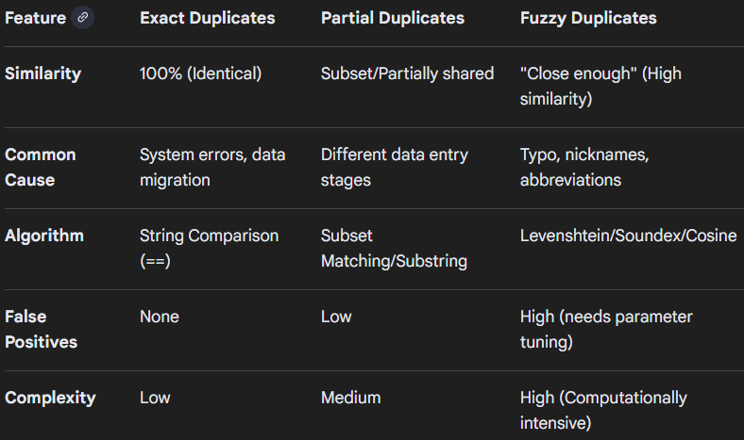

Question no 5:
Why should data validation be performed during transformation rather than after loading?
Answer:
Data validation should primarily be performed during the transformation phase (as part of the Extract, Transform, Load - ETL - process) rather than only after loading to catch errors early, prevent data contamination, reduce remediation costs, and ensure data readiness for immediate analysis.
Key Reasons for In-Transformation Validation
- Early Error Detection and Prevention: Validating data in motion catches issues closer to their source, preventing problematic data from moving downstream and contaminating other systems or the data warehouse itself. This "shift-left" testing approach, borrowed from software engineering, significantly reduces the burden of fixing errors later in the pipeline.
- Cost-Effectiveness: The cost of fixing data quality issues increases substantially the further along in the process they are discovered. By identifying and addressing invalid data during transformation, organizations avoid expensive and time-consuming data cleansing or rework after the data has been loaded.
- Ensuring Data Integrity and Quality: The transformation phase is where data is cleaned, standardized, and subjected to business rules. Validating at this stage ensures that only high-quality, reliable, and consistent data that meets predefined standards is loaded into the target system.
- Preventing Downstream Failures: Invalid data can cause downstream analytics, machine learning models, or application workflows to fail or produce misleading results. By validating before loading, teams ensure the data is fit for its intended use, fostering greater confidence and trust in the final output.
- Streamlined Error Handling: When validation fails during transformation, the pipeline can be designed to log the specific errors and quarantine the problematic records for review, while allowing the good data to continue processing. Post-load validation can make it more complex to isolate and manage individual errors within a large dataset.
- Regulatory Compliance: Industries with strict data regulations (like HIPAA or GDPR) require sensitive information to be handled with care. Pre-load transformations and validations ensure that sensitive data is appropriately masked or encrypted before it ever reaches the target database, reducing compliance risks.

While post-load auditing is still a valuable practice for overall data quality management, performing initial data validation during transformation is a crucial proactive strategy to maintain data integrity and optimize the efficiency of the entire data pipeline.

Question no 6:
Explain how business rules help in validating data accuracy. Give an example.
Answer:
Business rules validate data accuracy by defining logical constraints—such as mandatory fields, formats, and numerical ranges—that data must meet before entering a system, ensuring it is correct, consistent, and useful. These automated rules check for errors in real-time, preventing faulty information from causing operational or analytical issues.
Usage Examples & Techniques:
- Range Checks: Ensuring numeric data falls within a realistic scope (e.g., age cannot be less than 0).
- Consistency Checks: Confirming logic across fields (e.g., shipping date must be after order date).
- Format Checks: Verifying data structure (e.g., an email contains '@').
- Code Checks: Comparing input against a list of valid values (e.g., checking for a valid state code).
Example:
A banking application uses a business rule to ensure that when a customer makes a withdrawal, the "Withdrawal Amount" field is verified against the "Available Balance".

- Rule: If Withdrawal_Amount > Available_Balance, Then Reject_Transaction.
- How it helps: This prevents the business from recording inaccurate financial data (negative balances) and maintains data integrity by ensuring the transaction is valid before it is finalized.
Synonyms/Related Terms:
- Data Integrity Constraints
- Input Validation Rules
- Data Quality Rules
- Validation Logic
- Business Logic Checks

For example, a data integrity constraint on a database table might prevent deleting a customer if they have active, unpaid invoices.

